**Assignment-1**

1. **create a local git repository in your local machine first commit the initial code**

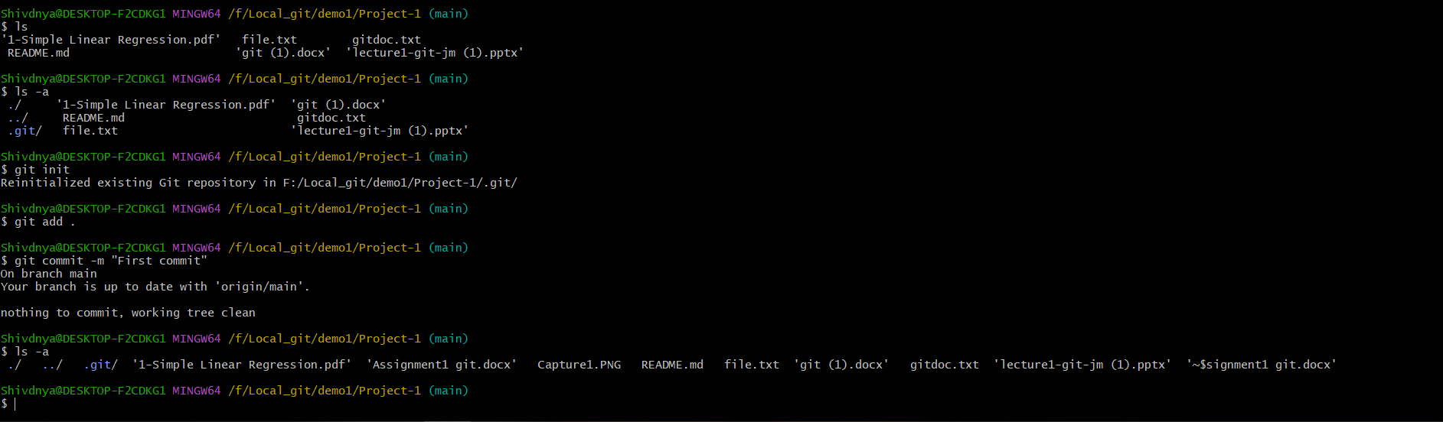

Q. Update the code on the remote server . Also perform some changes on  remote n reflect the same on local.[push/pull operations]